BSE Physiologist/Scientist-led services SOP

Physiologist/Scientist-led Transoesophageal Echocardiography and probe intubation
Authors- Elliot Smith (St George’s University Hospitals NHS Foundation Trust), Vitor Morgado (Royal Devon and Exeter NHS Foundation Trust)
- Introduction
This document is a guide to setting up physiologist/scientist-led transoesophaegeal echocardiography (TOE) services, with an emphasis on probe intubation. It outlines the key resources and processes required, based on the standard operating procedures of existing physiologist-led TOE services throughout the UK. It should be noted that this document is a guide only, and the authors acknowledge that individual NHS trusts may require additional processes to be in place before such a service can commence.
- Overview
Transoesophageal Echocardiography (TOE) is a diagnostic procedure whereby an ultrasound probe is passed into the patient’s oesophagus to take high resolution images of the heart. It plays an essential role in providing information to guide treatment for patients in a variety of settings, including those undergoing valve operations, patients with suspected endocarditis, or those where other imaging techniques were suboptimal or contraindicated.
In the UK TOE has traditionally been a consultant cardiologist-led service. However, increasing numbers of sonographers who are not medically-qualified are assuming this role in the UK (5). Due to the increasing demands on echocardiography services nationwide, there may be occasions (staff shortage, sickness, annual leave etc) where no consultant cardiologist is available to perform a TOE. Experienced Physiologists/Scientists specialised in echocardiography represent ideal potential candidates to lead a TOE due to their expert knowledge of echocardiography and cardiac anatomy. Although leading a TOE is outside of the conventional remit of a physiologist/scientist, the Health Education England document ‘multi-professional framework for advanced clinical practice in England’ states that ‘new solutions are required to deliver healthcare to meet the changing needs of the population, which will require new ways of working, new roles and new behaviours’ (1). Training cardiac physiology staff to perform and lead TOE will increase the capacity of the service, enabling shorter waiting times, faster diagnoses and more optimal patient treatment.
- Staffing requirements
Physiologist/Scientist- must have extensive experience in all aspects of echocardiography and hold BSE accreditation in TOE. Must hold registration with either the Registration Council of Clinical Physiologists, Academy of Healthcare Science or Health Care

Professions Council*. A trust-validated in date Immediate Life Support/Advanced Life Support certificate is also required.
(*statutory HCPC registration is not mandatory, however is desirable and may be more likely to obtain governance approval for advanced practice compared to voluntary registration (RCCP) (see section 4)).
Consultant Cardiologist(s)- must have extensive experience in performing TOE and be willing to train the physiologist/scientist. Must also be liable for any risk that occurs over the training period. Where possible, more than one cardiologist is recommended to provide multi-source feedback to the trainee.
Nurse/Registrar/other Health Professional- additional staff present within the TOE lab. Duties may include completion of WHO checklist, monitoring observations, providing suction, cannulation, administration of conscious sedation, operating machine controls etc.
- Equipment Requirements-
- Echocardiography machine with ECG cables and compatible TOE probe
- Examination couch/bed
- Sufficient facilities to clean and store TOE probes, along with necessary audit trail
- Suction equipment, oxygen supply, observation machine (minimum blood pressure and oxygen saturations, capnography advised if using conscious sedation)
- Fully stocked resuscitation trolley including anaphylaxis kit
- Emergency alarm call plus telephone with emergency bleep numbers.
- Local anaesthetic spray, nozzles and tongue depressor
- Mouth guard
- Cannulation equipment
- Conscious sedation and reversal agents
- Consent forms
- WHO checklists

- Governance approval-
As leading a TOE is outside of the traditional physiologist/scientist job role, it should be classified as advanced practice. As such, gaining approval from the appropriate local governance board is highly recommended prior to starting such a service. Further governance approval, along with an additional period of rigorous training and sign-off, should also be gained if the physiologist/scientist will be responsible for administration of intravenous sedation (5).
- Training
To obtain BSE TOE Accreditation, the Physiologist/Scientist will have to successfully pass a theory exam, perform/report 125 scans (75 if TTE accredited), submit 5 video cases and pass a VIVA examination on a simulator.
Prior to learning intubation, it is recommended that the Scientist/Physiologist has at least 12 months’ experience of observing intubation and performing TOE on already intubated patients across a variety of settings (echo lab, ICU, theatres/cathlabs). As TOE is a similar

procedure to upper gastrointestinal endoscopy, additional learning from endoscopy courses/resources is also recommended (see Appendix 1 for useful links).
Direct hands-on intubation teaching and supervision should be provided by the consultant cardiologist(s) throughout the training period. Intubation is not covered in BSE TOE accreditation; however other sources have suggested a minimum of 25 successful intubations before being deemed competent (2). This number is just a guide, and it is understood that fewer or more successful intubations may be required before either party are content with being deemed competent. Direct supervision should continue until the trainee can safely and consistently intubate (3). A log of the attempted intubations should be kept by the trainee throughout the training period and co-signed by the supervisor (see appendix 2). This log should be maintained after the sign-off period to enable to the service to be audited going forward.
- Clinical Supervision
All attempted intubations should be directly supervised by a consultant cardiologist throughout the training period. Even after competency has been achieved it is recommended that a consultant cardiologist is available on-site in case of any complications during a physiologist/scientist led TOE.
- Continued Professional Development
In order to maintain BSE TOE accreditation the physiologist/scientist must perform >50 TOEs per year, as well as obtaining >50 re-accreditation points over a 5 year period by attending relevant courses and conferences. It is recommended that endoscopy-related courses are included in these so that the Scientist/Physiologist stays up to date in this field. There is no specified number of intubations per year required to maintain accreditation.
- Inclusion/exclusion criteria
Patients who are excluded from Physiologist/Scientist intubation include those who have contraindications to TOE (see Appendix 3), and those who have a history of difficult intubation that will require a consultant and/or general anaesthesia. Any who have a relative contraindication to TOE must be discussed with the overseeing cardiologist prior to attempting intubation.
- Protocol
- Pre-test – WHO checklist (see Appendix 4) and a written consent form must be completed prior to starting the test. Any concerns raised on the WHO checklist should be discussed with a consultant cardiologist prior to starting the test. If the physiologist/scientist is leading the TOE it is recommended that they personally consent the patient and co-sign the consent form*. (* note- local trust policy may dictate that the scientist/physiologist should complete a local consent course prior to independently consenting patients).
- Consent form suggested content-
  - Name of procedure- transoesophageal echocardiogram
  - Intended benefits- to assess heart valves, structure and function

  - Associated risks- minor oral bleeding or throat discomfort post-procedure, low risk of aspiration and infection, approximate 1:10,000 risk of serious oesophageal damage, cardiac arrhythmia
- A cannula should be inserted if sedation is required/likely to be needed during the test.
- Monitoring equipment is attached to the patient. This should include ECG, blood pressure and oxygen saturation monitoring. Suction should be available. This is usually the responsibility of the nurse assisting the procedure.
- The patient’s oropharynx is anaesthetised using a topical administration of a Xylocaine 10mg spray. Typically, 3 rounds of 5 sprays provide suitable anaesthesia. Spray should be applied to the posterior pharyngeal wall, as well as tongue, pallet and tonsil pillars to facilitate probe passage and minimise need for conscious sedation. A tongue depressor may be necessary to ensure the spray reaches these areas (4). After each round of spray, the patient is asked to gargle before swallowing to ensure widespread coverage
- Patient is positioned in the left lateral decubitus position. A mouth guard is inserted for protection. Suction and continuous observations are performed by the nurse/responsible healthcare professional.
- If sedation is required, then it should be administered by the responsible individual according to the BSE safe sedation guideline (5). Reversal agents should be immediately available, with a fully stocked resuscitation trolley located in the department.
- Sterile lubrication gel is applied to a cleaned TOE probe (6) to facilitate probe passage. The probe is inserted through the mouth guard to the back of the pharynx, which may require slight anteflexion on the probe controls. Once in position, the patient is asked to swallow and the probe is advanced down the oesophagus in a neutral position as the patient swallows. It should remain in the neutral position and mid-line in the pharynx to avoid placing the probe in the piriform fossa. With a mouth guard in place it is safe to insert a finger into the mouth to guide the probe towards the midline and depress the tongue if it blocks passage (4).
- If intubation is unsuccessful the probe should be gently withdrawn and mouth guard removed. Suction should be provided. The patient is reassured, instructions are repeated, and more local anaesthetic may be necessary. In cases of difficult intubations, guidance from a consultant cardiologist should be sought, with a low threshold for abandoning the test to be re-booked under a more experienced operator or general anaesthesia. The exact number of failed attempted intubations before help is sought will be dependent on local policy and operator experience.
- Following completion of the TOE study, the probe is returned to a neutral unlocked position and gently withdrawn from the oesophagus. Suction should again be provided immediately following withdrawal to avoid aspiration. The probe should be checked for any signs of excessive bleeding that may indicate a procedural

complication. Post procedural observations are taken and recorded on the WHO checklist.
- Patients should be monitored post-procedure according to local protocols and whether they received conscious sedation (5). Patients should remain nil-by-mouth 1 hour post-procedure. After 1 hour they can start to have small sips of cold fluids, after 2 hours they can eat and drink normally.
- The TOE report, Consent forms and WHO checklist should all be fully completed and stored according to local protocols.

- Risks and emergency protocols
TOE is generally considered a safe procedure. It has a suggested safety profile comparable to routine upper gastrointestinal endoscopy, with a complication rate of 0.08-0.13%, and mortality rate of 0.004% (7).
Potential risks are identified by the pre-procedural completion of the WHO Checklist (see appendix 4) and minimised during the procedure by fasting the patient, continuous monitoring of observations and airway, mouth guard insertion, and minimising probe flexion and contact time. The probe must be left in the unlocked position at all times during insertion and removal (7).
All associated risks are explained to the patient prior to signing the consent form. Minor injuries associated with TOE are listed in the Appendix 5. The most serious associated complication is oesophageal perforation. It is rare, with a reported incidence of 0.01-0.09%. It should be suspected in any patient presenting with tachypnea, pneumothorax, pleural effusion, subcutaneous emphysema or excessive oro-gastric bleeding immediately post-TOE. Failure to obtain good quality TOE images in the absence of probe dysfunction should also raise suspicion (7). If oesophageal perforation is suspected, then the supervising consultant should be informed and the on-call gastroenterology registrar/consultant should be contacted immediately (according to local policy).
TOE carries a risk of cross infection due to its invasive nature. However, adherence to the BSE guidelines on TOE probe cleaning and disinfection minimise this (6).
The final major associated risk, although extremely rare, is the patient developing arrhythmia during the procedure. Most commonly these are self-limiting and of no consequence. However, there are isolated case reports of sustained significant arrhythmia during TOE (5). If sustained ventricular arrhythmia is encountered during TOE then the probe should be removed and the patient should be treated according to the resuscitation guidelines (6). The cardiac arrest team should be called immediately (2222). A fully stocked and regularly checked resuscitation trolley should be available nearby.
Any procedural related complications should be clearly noted in the audit log (see Appendix 2) and be documented as per local policy (e.g. incident forms etc).

- Service Evaluation
The physiologist/scientist intubation log should be audited going forward in conjunction with an annual appraisal to assess the safety and efficacy of the service.
- References
1. https://www.hee.nhs.uk/sites/default/files/documents/Multi-professional%20framework%20for%20advanced%20clinical%20practice%20in%20England.pdf
2. Jan Poelaert, Karl Skarvan (2008). Transoesophageal Echocardiography in Anaesthesia and Intensive Care Medicine. Page 317.
3. Cahalan et al. (2002) American Society of Echocardiography and the Society of Cardiovascular Anaesthesiologists task force guidelines for training in perioperative echocardiography. Journal for the American Society of Echocardiography, 15:647-52, 647-652. http://dx.doi.org/10.1067/mje.2002.123956
4. Hahn et al. (2013) Guidelines for performing a comprehensive transoesophageal echocardiographic examination: Recommendations from the American Society of Echocardiography and the Society of Cardiovascular Anaesthesiologists. Journal for the American Society of Echocardiography, 26:921-64, 921-964. http://dx.doi.org/10.1016/j.echo.2013.07.009
5. Recommendations for Safe Practice in Transoesophageal Echocardiography (bsecho.org)5
6. Joint Recommendations for Transoesophageal Probe Cleaning and Disinfection: a Collaboration of the British Society of Echocard (bsecho.org)
7. Hauser, N.D. and Swanevelder, J (2018). Transoesophageal echocardiography (TOE): contra-indications, complication and safety of perioperative TOE. Echo Research and Practice, 5:4. R101-E113. https://doi.org/10.1530/ERP-18-0047

Appendix 1- endoscopy learning resources
JETS – JAG Endoscopy Training System (thejag.org.uk)
Endoscopy - e-Learning for Healthcare (e-lfh.org.uk)

Appendix 2- suggested structure of intubation log
- Date
- Patient demographics (MRN, DOB)
- Indication
- Sedation required (yes/no)
- Intubation success (yes/no)
- Attempts
- Consultant support required (yes/no)
- Supervising consultant
- Complications
- Consultant sign-off
Appendix 3- Absolute and relative contraindications for TOE. Taken from Hauser et al. (2018).
Absolute Contraindications | Relative Contraindications
Oesophageal stricture | Oesophageal varices
Trachea-oesophageal fistula | Barret’s oesophagus
Oesophageal trauma | Zencker’s diverticulum
Oesophageal surgery/oesophagectomy | Oesophageal carcinoma
Perforated viscus | Previous thoracic radiotherapy
 | Mallory-Weiss tear
 | Colonic interposition
 | Previous bariatric surgery
 | Dysphagia
 | Coagulopathy/bleeding disorder
 | Atlanto-axial joint disease limiting cervical mobility
 | Severe cervical osteoarthritis
 | Thoracic aortic aneurysm

Appendix 4- WHO checklist
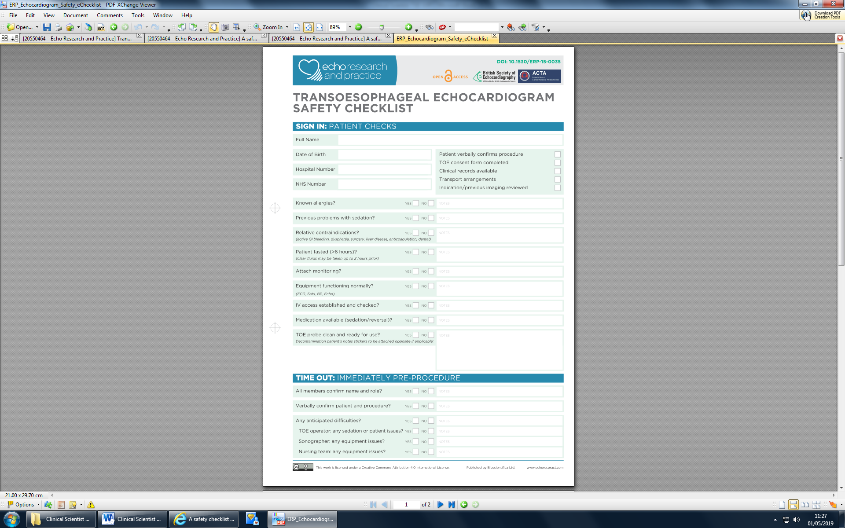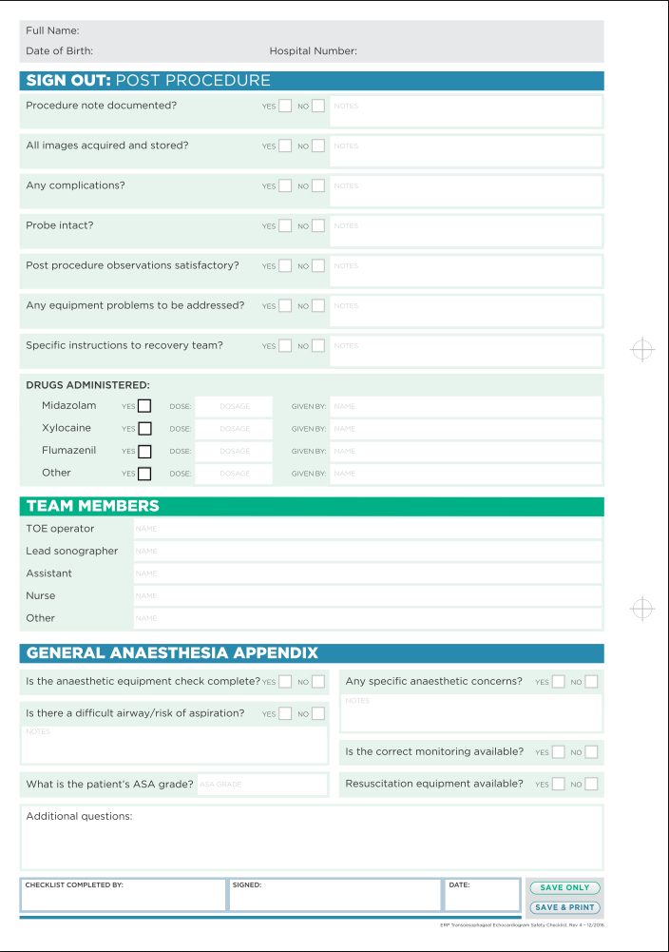

Appendix 5- Minor injuries associated with TOE. Taken from Hauser et al. (2018).

Site of injury | Injury
Oral | Lip bruising/laceration, tongue laceration/minor swelling, dental chipping, dental loosening, denture displacement, hoarseness
Oesophageal | Minor laceration, odynophagia, Mallory-Weiss with limited GI bleeding only
Gastric | Minor laceration with limited GI bleeding only
Cardiovascular | Self-limiting arrhythmia without hemodynamic compromise

